***COP ASSIGNMENT 3***

***ARRAYS***

**QUESTION 1**

**QUESTION 1**

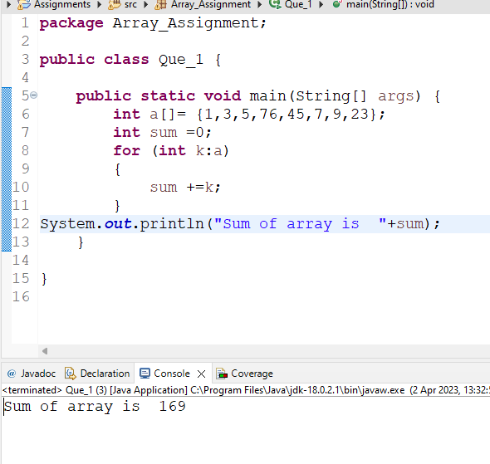

**QUESTION 2**

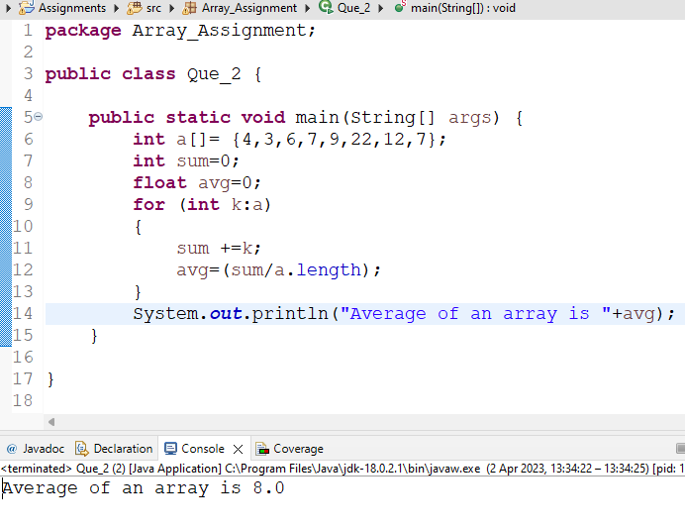

**QUESTION 3**

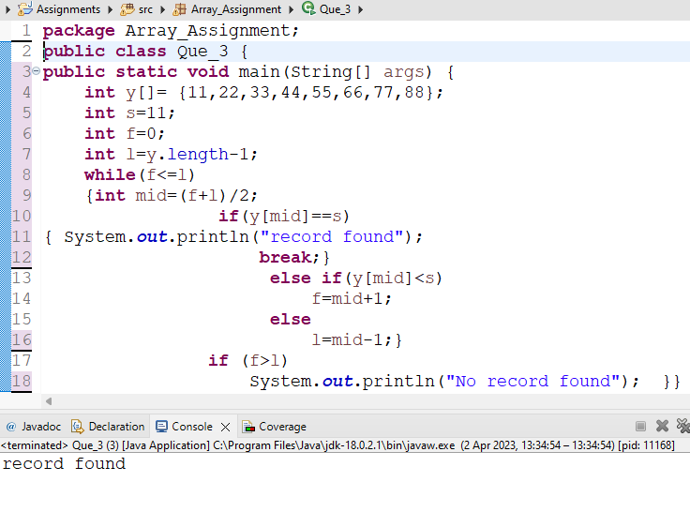

**QUESTION 4**

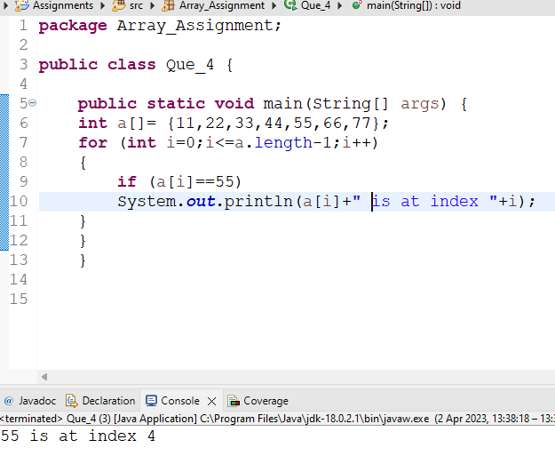

**QUESTION 5**

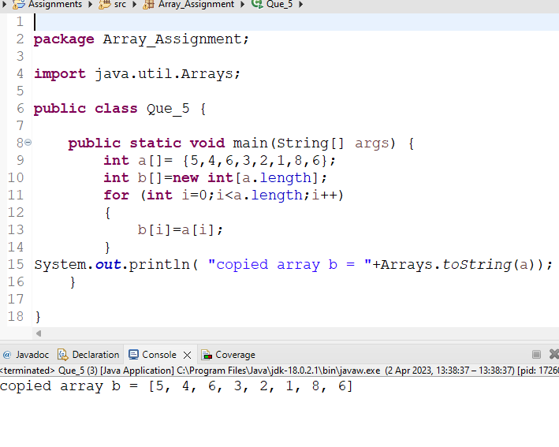

**QUESTION 6**

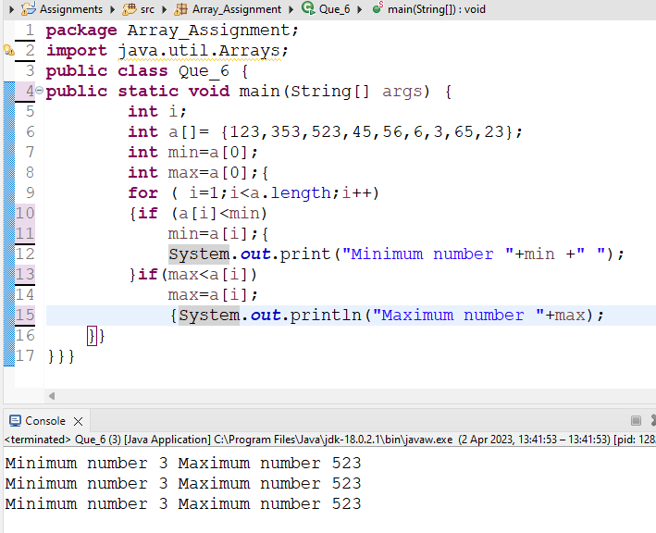

**QUESTION 7**

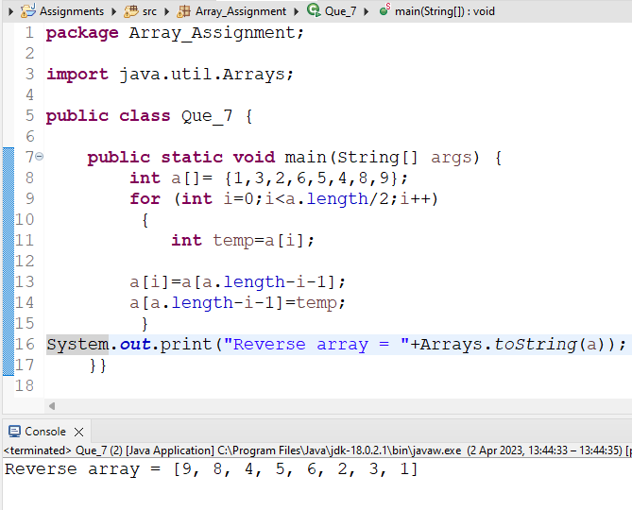

**QUESTION 8**

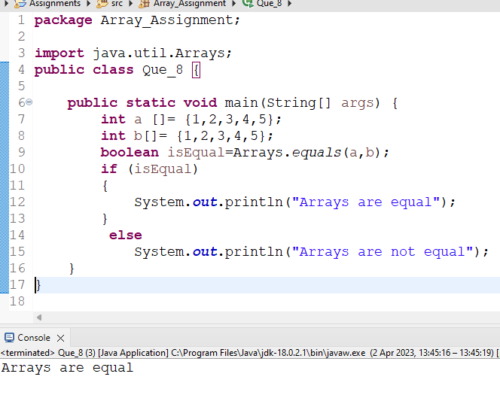

**QUESTION 9**

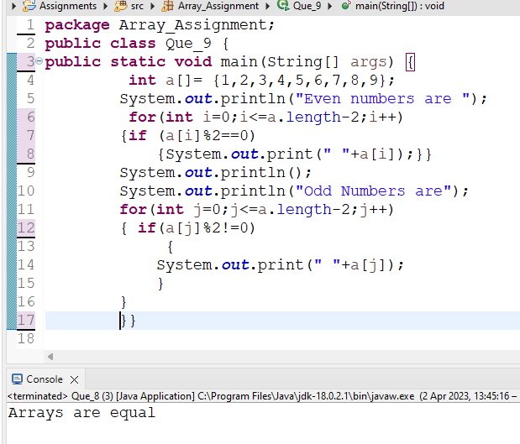

**QUESTION 10**

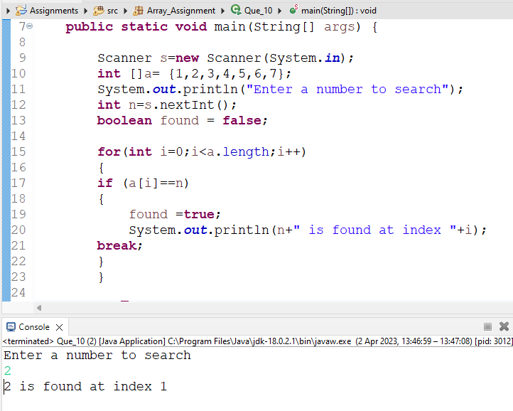

**QUESTION 11**

